**Evolution of Opsins and Bat Adaptation to Dark Conditions**

**Introduction**

Bats represent one of the most unique groups of mammals, possessing remarkable adaptations that make them excellent models for studying the evolution of perception of the surrounding world. There are over 1,260 species of bats that successfully inhabit various ecological niches worldwide, feeding on insects, small mammals, fish, blood, nectar, and fruit. Bats are the only mammals capable of true flight, and they utilize the unique ability of echolocation for hunting and navigating in low-light conditions.

Opsins - light-sensitive proteins found in the photoreceptors of the retina—play a crucial role in light perception in bats. Each opsin is encoded by a separate gene, and different types of opsins are responsible for color and light perception under various conditions. The evolution of opsins is linked to adaptation to living conditions, and studies indicate that some bat species have lost one type of opsin, which may be associated with the development of echolocation and lifestyle characteristics.

This study aims to elucidate the evolutionary relationships among various bat species, investigate the presence of common mutations in opsin genes that might indicate adaptation to low-light living conditions, and determine whether cave-dwelling bats form a monophyletic clade.

**Methods**

For the phylogenetic analysis, 12 species of bats were selected. Data on opsin sequences (OPN1SW) were obtained from the GenBank database (<https://www.ncbi.nlm.nih.gov/popset/1524845346>). The house mouse (Mus musculus) was used as the outgroup. Various types of opsins, including rhodopsin and cone pigments, have been well studied in mice.

Sequences were assembled and aligned in FASTA format. Sequence alignment was performed using the MAFFT program.

The phylogenetic tree was constructed using two different methods: the distance method (maximum likelihood) and Bayesian analysis.

1. **Distance Method:** The IQ-TREE software package was used for analysis. The analysis was performed with 1,000 bootstrap replicates to assess branch reliability in the tree.
2. **Bayesian Analysis:** This analysis was performed using the MrBayes program. A Nexus format file was prepared for this purpose.

Phylogenetic trees were visualized using the MEGA software, allowing for the assessment and interpretation of the results. The trees were exported in image format for further use in the report.

**Results**

Phylogenetic trees constructed based on opsin sequences (OPN1SW) in bats were obtained using two different methods: the maximum likelihood method and Bayesian analysis.

1. **Tree constructed using the maximum likelihood method (IQ-TREE):** The tree shows that diurnal and crepuscular species, such as *Cynopterus sphinx*, *Epomophorus wahlbergi*, *Desmodus rotundus*, and *Dyacopterus rickarti*, form a clade with high bootstrap support values (for example, nodes with a value of 100), confirming their close evolutionary relationship. Nocturnal and cave species, such as *Anoura geoffroyi* and *Furipterus horrens*, occupy different branches on the tree and do not form a monophyletic group, indicating independent loss of function of the OPN1SW gene under low-light conditions.

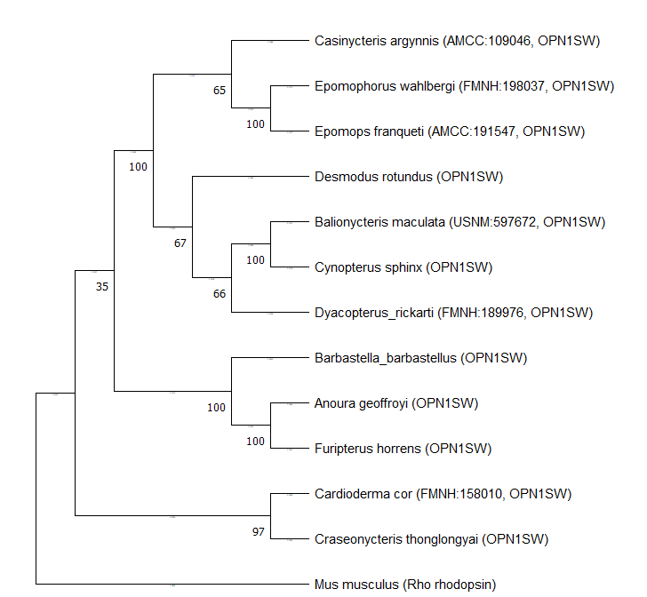

1. **Tree constructed using Bayesian analysis (MrBayes):** This tree exhibits a similar structure: diurnal species are grouped together, demonstrating strong cluster support (*Epomophorus wahlbergi*, *Balaionycteris maculata*, *Cynopterus sphinx*). Species adapted to nocturnal and cave lifestyles, such as *Barbastella barbastellus*, *Anoura geoffroyi*, and *Furipterus horrens*, are also divided into different clades, supporting the hypothesis of convergent evolution of adaptations to darkness.

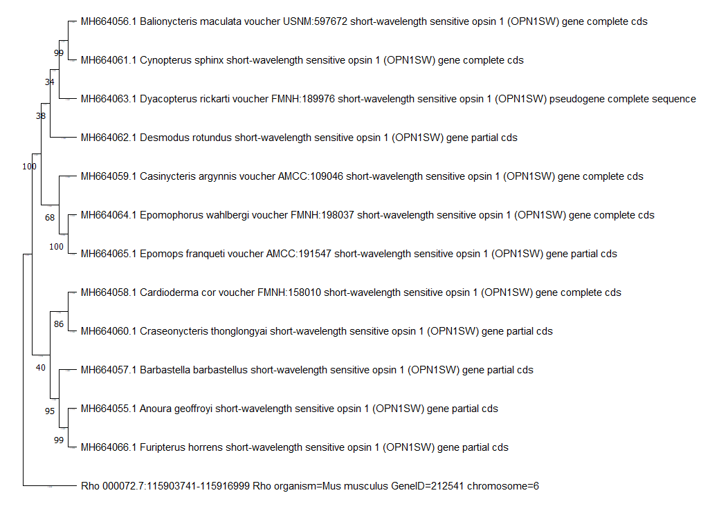

**Discussion of Results**

These data indicate significant evolutionary differences in the visual adaptations of bats.

1. **Diurnal species retain the functionality of the OPN1SW gene**, allowing them to utilize color vision, which is important for foraging in well-lit conditions. For example, *Cynopterus sphinx* and *Epomophorus wahlbergi* have high support values in phylogenetic clusters, which may indicate a common ancestor adapted to a diurnal lifestyle. This suggests that the retention of OPN1SW is critically important for diurnal species, as it aids in locating fruits and flowers.
2. **Nocturnal and cave species, in contrast, have lost the need for color vision**, as their habitats do not require color differentiation. The tree shows that these species do not form a single clade, indicating that adaptation to darkness occurred independently in different species (convergent evolution). For instance, *Anoura geoffroyi*, *Furipterus horrens*, and *Barbastella barbastellus* are positioned on different branches, indicating independent mutations in the OPN1SW gene leading to reduced visual pigment functions. This suggests that each species adapted to low-light conditions in different ways.
3. **Convergent evolution:** These data also support the hypothesis of convergent evolution. Although nocturnal species are not genetically closely related, they have developed a similar trait—loss or alteration of the function of the OPN1SW gene. This demonstrates how different species can arrive at analogous adaptations when faced with similar ecological challenges (e.g., living in darkness).
4. **Role of ecological factors:** The results indicate that ecological conditions, such as the presence or absence of light, play a key role in the evolution of visual systems in bats. Diurnal species inhabiting well-lit environments retain functional opsins for color vision, while nocturnal and cave species have adapted to life in darkness, losing the need for such opsins.

**Conclusion**

The study of the evolution of opsins and bat adaptations to dark conditions demonstrates significant differences in the visual systems of these animals. The results show that diurnal species, which retain the functionality of the OPN1SW gene, are capable of utilizing color vision, which is critically important for their survival in well-lit environments. At the same time, nocturnal and cave-dwelling species have shown independent loss of this gene, confirming the hypothesis of convergent evolution in response to similar ecological challenges. These findings highlight how ecological factors, such as light levels, influence the evolution of visual systems in bats and open new perspectives for further research into animal adaptations to various living conditions.